2.2 Product Functions.

CRM Software should support the following use cases:

|  |  |  |  |
| --- | --- | --- | --- |
| CLASS OF USE CASES | № | USE CASES | DESCRIPTION OF USE CASES |
| Related to System Authentication |  | **Login** | *Login into the CRM* |
|  | **Change Password** | *Changes the password* |
| Related to Activity Stream |  | **Post Message** | *Posts a Message to the AS* |
|  | **Delete Message** | *Deletes a Message from the AS* |
|  | **Request Approval** | *Requests an Approval from Manager* |
| Related to Tasks |  | **Create Task** | *Creates a new Task* |
|  | **Execute Task** | *Execution of the task is started* |
|  | **Finish Task** | *Finishes the Task* |
|  | **Delete Task** | *Delete the Task* |
| Related to Calendar |  | **Create Event** | *Creates a new Event* |
|  | **Delete Event** | *Deletes an Event* |
| Related to CRM |  | **Add Contact** | *Adds a Contact* |
|  | **Delete Contact** | *Delete the Contact* |
|  | **Add Company** | *Adds a Company* |
|  | **Delete Company** | *Delete the Company* |
|  | **Create Activity** | *Creates an Activity* |
|  | **Finish Activity** | *Finishes an Activity* |
|  | **Delete Activity** | *Deletes an Activity* |
| Related to Information Display |  | **Display Message** | *Display information about the message* |
|  | **Display Request** | *Display information about the request* |
|  | **Display Task** | *Display information about the task* |
|  | **Display Event** | *Display information about the event* |
|  | **Display Contact** | *Display information about the contact* |
|  | **Display Company** | *Display information about the company* |
|  | **Display Activity** | *Display information about the activity* |

3 Specific Requirements

3.1 Functional Requirements.  
We describe the functional requirements by giving various use cases.

*Use cases related to System Authentication:*

*Use Case:* Login  
*Primary Actor*: User  
*Pre Condition*: Installed browser and an available internet connection   
*Main scenario*:

1. User initiates a browser
2. User specifies the web address of the CRM
3. User gives the login and password
4. System does authentication
5. Activity Stream is displayed

*Alternate scenario:*  
 5.1 Authorization fails – wrong username/password  
 5.1.1 Prompt the user that he typed the username/password wrong  
 5.1.2 Allow him to re-enter the username/password  
 5.2 Authorization fails – forgotten username/password  
 5.2.1 Prompt the user to enter his registered email  
 5.2.2 User receives an email with instructions about his login credentials

*Use Case*: Change password  
*Primary Actor*: User  
*Pre Condition*: User logged in   
*Main scenario*:

1. User goes to his Bitrix24.Network Page
2. User goes to Edit Profile
3. User goes to Change Password
4. User enters his current Password and types two times the new one
5. System displays message for successful change

*Alternate scenario:*  
 5.1 Authorization fails – wrong password  
 5.1.1 Prompt the user that he typed the password wrong  
 5.1.2 Allow him to re-enter the password  
 5.2 Authorization fails – forgotten username/password  
 5.2.1 New password and confirm new password do not match  
 5.2.2 Allow him to re-enter the attributes.

*Use cases related to Activity Stream:*

*Use Case:* Post Message   
*Primary Actor*: User  
*Pre Condition*: User logged in   
*Main scenario*:

1. User initiates the “Post Message” functionality in Activity Stream
2. User enters the message text
3. User specifies attachments (if necessary)
4. User specifies recipients
5. User posts the message
6. Message is created
7. All recipients receive a notification with link to view the message

*Alternate scenario:*  
 8.1 Post Message cancelation  
 8.1.1 “Post Message” functionality is canceled

*Use Case:* Delete Message   
*Primary Actor*: User  
*Pre Condition*: User logged in   
*Main scenario*:

1. User initiates the “Delete Message” functionality
2. System displays a confirmation message
3. System displays a successful deletion message
4. Message is deleted

*Alternate scenario:*  
 5.1 Delete Message cancelation  
 5.1.1 “Delete Message” functionality is canceled

*Use Case:* Request Approval   
*Primary Actor*: User  
*Pre Condition*: User logged in   
*Main scenario*:

1. User initiates the “Processes” functionality in Activity Stream
2. User specifies absence type
3. User specifies reasons
4. User sends the request approval
5. Activity stream displays the status of the request
6. The approver receives a notification about the request
7. User receives the approvers decision

*Alternate scenario:*  
 8.1 Request Approval cancelation  
 8.1.1 “Request Approval” functionality is canceled

*Use cases related to Tasks:*

*Use Case:* Create Task  
*Primary Actor*: User  
*Pre Condition*: User logged in   
*Main scenario*:

1. User initiates the “Create Task” functionality in “Tasks”
2. User enters a name for the task
3. User specifies responsible person
4. User specifies deadline for completion
5. User enters the task description
6. Task is created
7. System creates and assigns the task to the responsible person
8. System sends notification to the responsible person

*Alternate scenario:*  
 9.1 Create Task cancelation  
 9.1.1 “Create Task” functionality is canceled

*Use Case:* Execute Task  
*Primary Actor*: User  
*Pre Condition*: User logged in   
*Scenario*:

1. User selects the task
2. User initiates the “Execute Task” functionality
3. Task execution is started

*Use Case:* Finish Task  
*Primary Actor*: User  
*Pre Condition*: User logged in   
*Scenario*:

1. User selects the task
2. User initiates the “Finish Task” functionality
3. System marks the task as completed

*Use Case:* Delete Task  
*Primary Actor*: User  
*Pre Condition*: User logged in   
*Main scenario*:

1. User selects the task
2. User initiates the “Delete Task” functionality
3. System displays a confirmation message
4. Task is deleted

*Alternate scenario:*  
 5.1 Delete task cancelation  
 5.1.1 “Delete task” functionality is canceled

*Use cases related to Calendar:*

*Use Case:* Create Event  
*Primary Actor*: User  
*Pre Condition*: User logged in   
*Main scenario*:

1. User initiates the “Create Event” functionality in Calendar
2. User enters start and end time and sets reminders
3. User specifies event name and location
4. User specifies event description
5. User adds participants (if needed)
6. User submits the event
7. Event is created
8. System sends notifications to the participants
9. System sends reminders

*Alternate scenario:*  
 9.1 Create Event cancelation  
 9.1.1 “Create Event” functionality is canceled

*Use Case:* Delete Event  
*Primary Actor*: User  
*Pre Condition*: User logged in   
*Main scenario*:

1. User selects the event
2. User initiates the “Delete Event” functionality
3. System displays a confirmation message
4. Event is deleted

*Alternate scenario:*  
 5.1 Delete event cancelation  
 5.1.1 “Delete Event” functionality is canceled

*Use cases related to CRM:*

*Use Case:* Add Contact  
*Primary Actor*: User  
*Pre Condition*: User logged in   
*Main scenario*:

1. User initiates the “Add Contact” functionality in CRM
2. User specifies first and last names of the contact
3. User specifies email
4. User specifies phone
5. User specifies Company (if necessary)
6. User specifies contact type
7. User specifies responsible person
8. A contact is created

*Alternate scenario:*  
 8.1. Add Contact cancelation  
 8.1.1. “Add Contact” functionality is canceled  
 8.2. Contact with the same information exists  
 8.2.1. System asks the user for different information  
 8.2.1. Contact is created  
 8.2.2. System asks the user for merging with existing contact  
 8.2.1. Contact is merged  
 8.2.3. System cancels the “Add Contact” functionality

*Use Case:* Delete Contact  
*Primary Actor*: User  
*Pre Condition*: User logged in   
*Main scenario*:

1. User selects the contact in CRM
2. User initiates the “Delete Contact” functionality
3. System displays a confirmation message
4. Contact is deleted

*Alternate scenario:*  
 4.1 Delete Contact cancelation  
 4.1.1 “Delete Contact” functionality is canceled

*Use Case:* Add Company  
*Primary Actor*: User  
*Pre Condition*: User logged in   
*Main scenario*:

1. User initiates the “Add Company” functionality in CRM
2. User specifies company name
3. User specifies responsible person
4. User specifies company information
5. User associates employees / contacts (if present)
6. User submits the company form

*Alternate scenario:*  
 6.1. Add Company cancelation  
 6.1.1. “Add Company” functionality is canceled  
 6.2. Company with the same information exists  
 6.2.1. System asks the user for different information  
 6.2.1. Company is created  
 6.2.2. System asks the user for merging with existing Company  
 6.2.1. Company is merged  
 6.2.3. System cancels the “Add Company” functionality

*Use Case:* Delete Company  
*Primary Actor*: User  
*Pre Condition*: User logged in   
*Main scenario*:

1. User selects the company in CRM
2. User initiates the “Delete Company” functionality
3. System displays a confirmation message
4. Company is deleted

*Alternate scenario:*  
 4.1 Delete Company cancelation  
 4.1.1 “Delete Company” functionality is canceled

*Use Case:* Create Activity  
*Primary Actor*: User  
*Pre Condition*: User logged in   
*Main scenario*:

1. User initiates the “Create Activity” functionality in CRM
2. User specifies the activity type (call or meeting)
3. User specifies date and reminder
4. User specifies where/with information
5. User specifies subject and information
6. User specifies responsible person
7. An activity is created
8. System sends notification and reminders

*Alternate scenario:*  
 8.1. Create activity cancelation  
 8.1.1. “Create Activity” functionality is canceled

*Use Case:* Finish Activity  
*Primary Actor*: User  
*Pre Condition*: User logged in   
*Scenario*:

1. User selects the activity
2. User initiates the “Finish Activity” functionality in CRM
3. System marks the activity as finished

*Use Case:* Delete Activity  
*Primary Actor*: User  
*Pre Condition*: User logged in   
*Main scenario*:

1. User selects the activity
2. User initiates the “Delete Activity” functionality
3. System displays a confirmation message
4. Activity is deleted

*Alternate scenario:*  
 4.1 Delete activity cancelation  
 4.1.1 “Delete Activity” functionality is canceled

*Use cases related to Information Display:*

*Use Case:* Display Message  
*Primary Actor*: User  
*Pre Condition*: User logged in   
*Scenario*:

1. Message is displayed in “Activity Stream”

*Use Case:* Display Request  
*Primary Actor*: User  
*Pre Condition*: User logged in   
*Scenario*:

1. Request is displayed in “Activity Stream”

*Use Case:* Display Task  
*Primary Actor*: User  
*Pre Condition*: User logged in   
*Scenario*:

1. User selects a task from “Tasks”
2. System displays the Task information

*Use Case:* Display Event  
*Primary Actor*: User  
*Pre Condition*: User logged in   
*Scenario*:

1. User selects an event from “Calendar”
2. System displays the event information

*Use Case:* Display Contact  
*Primary Actor*: User  
*Pre Condition*: User logged in   
*Scenario*:

1. User selects a contact from “CRM”
2. System displays the contact information

*Use Case:* Display Company  
*Primary Actor*: User  
*Pre Condition*: User logged in   
*Scenario*:

1. User selects a company from “CRM”
2. System displays the contact information

*Use Case:* Display Activity  
*Primary Actor*: User  
*Pre Condition*: User logged in   
*Scenario*:

1. User selects an activity from “CRM”
2. System displays the activity information

4. Appendix: User Screens

1. Login

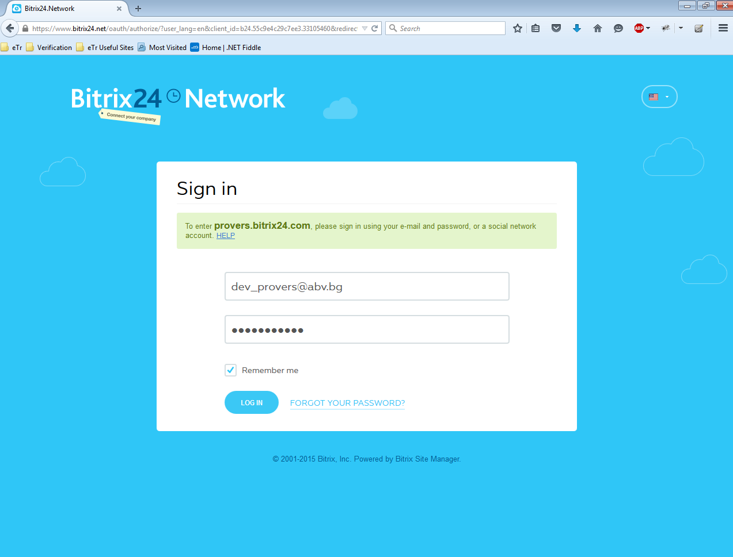

1. Bitrix Network

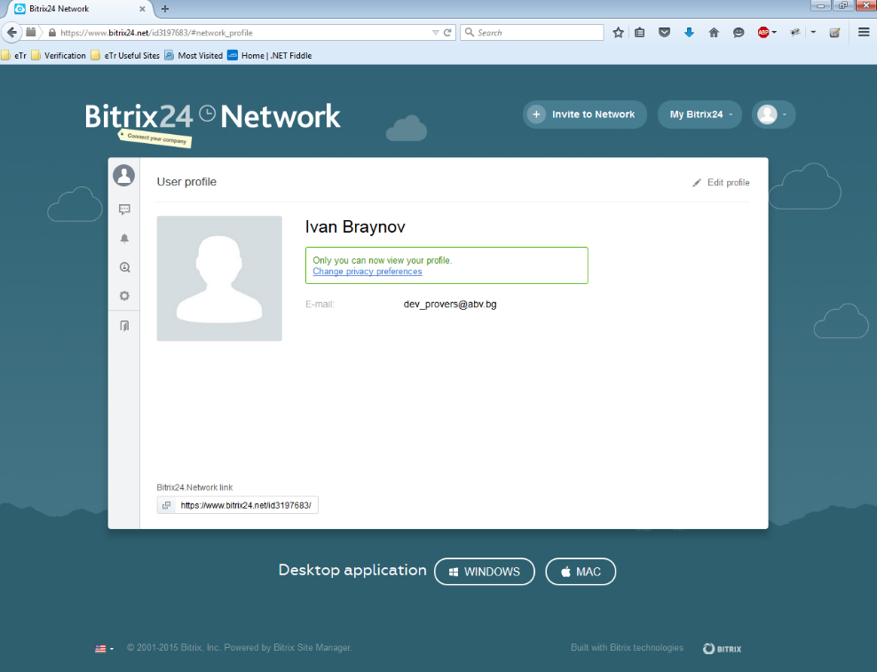

1. Activity Stream

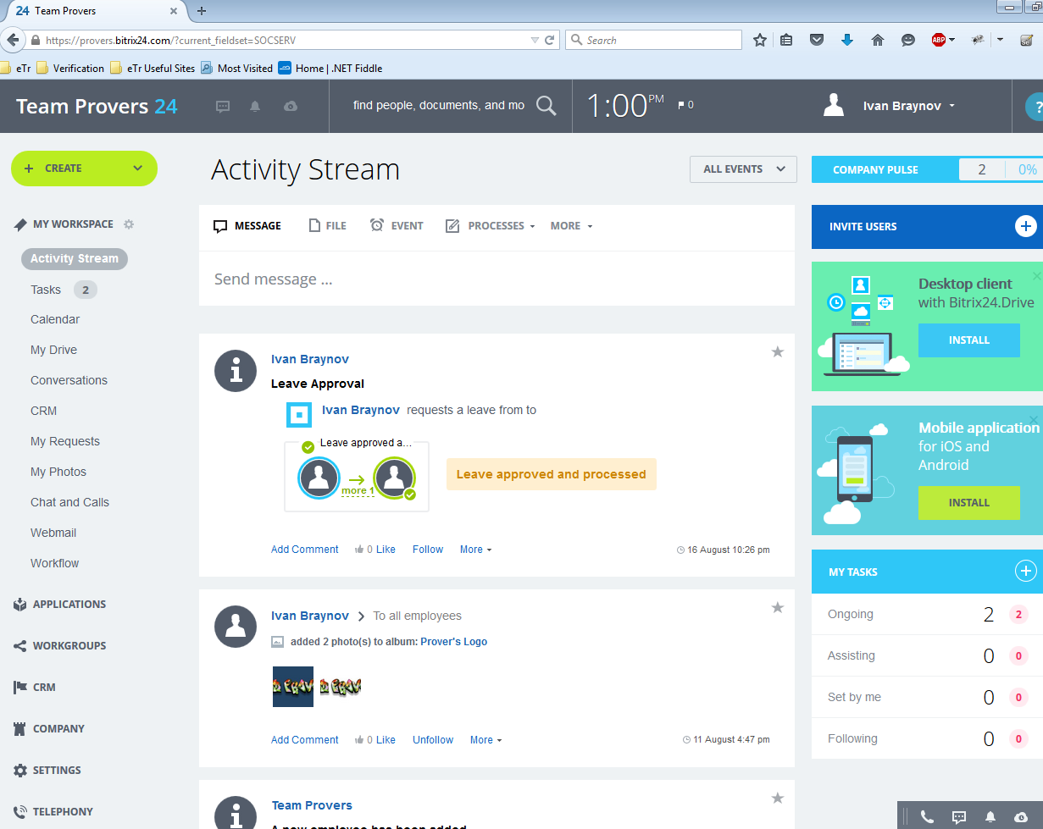

1. Tasks

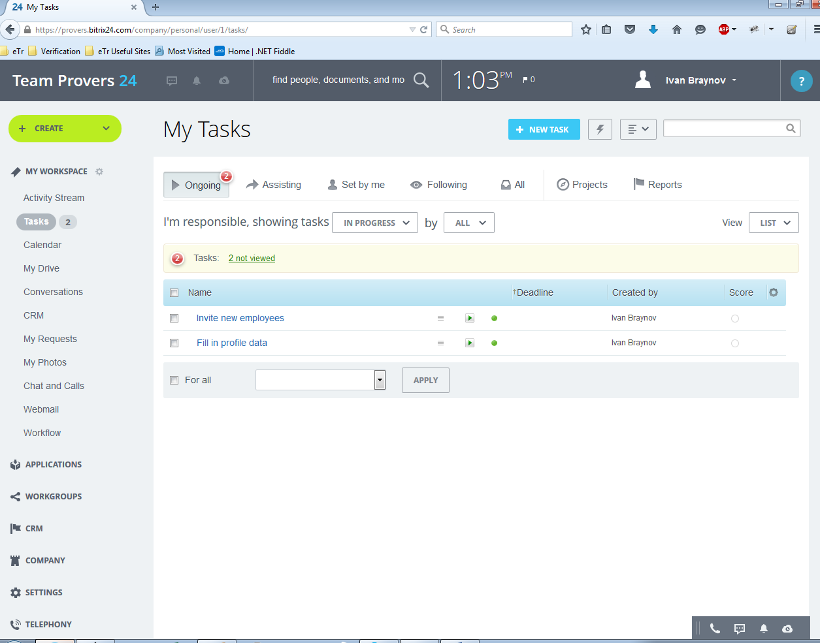

1. Calendar

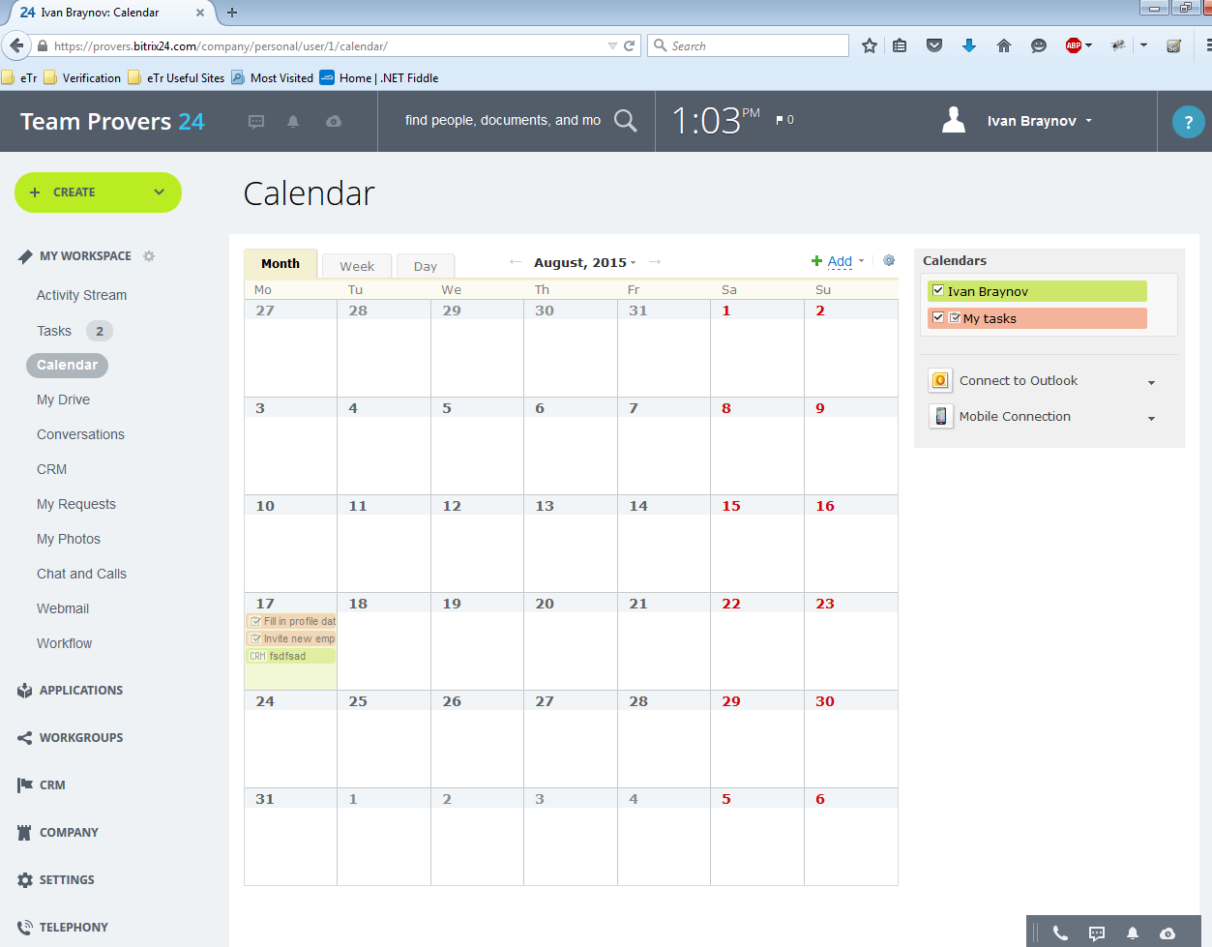

1. CRM

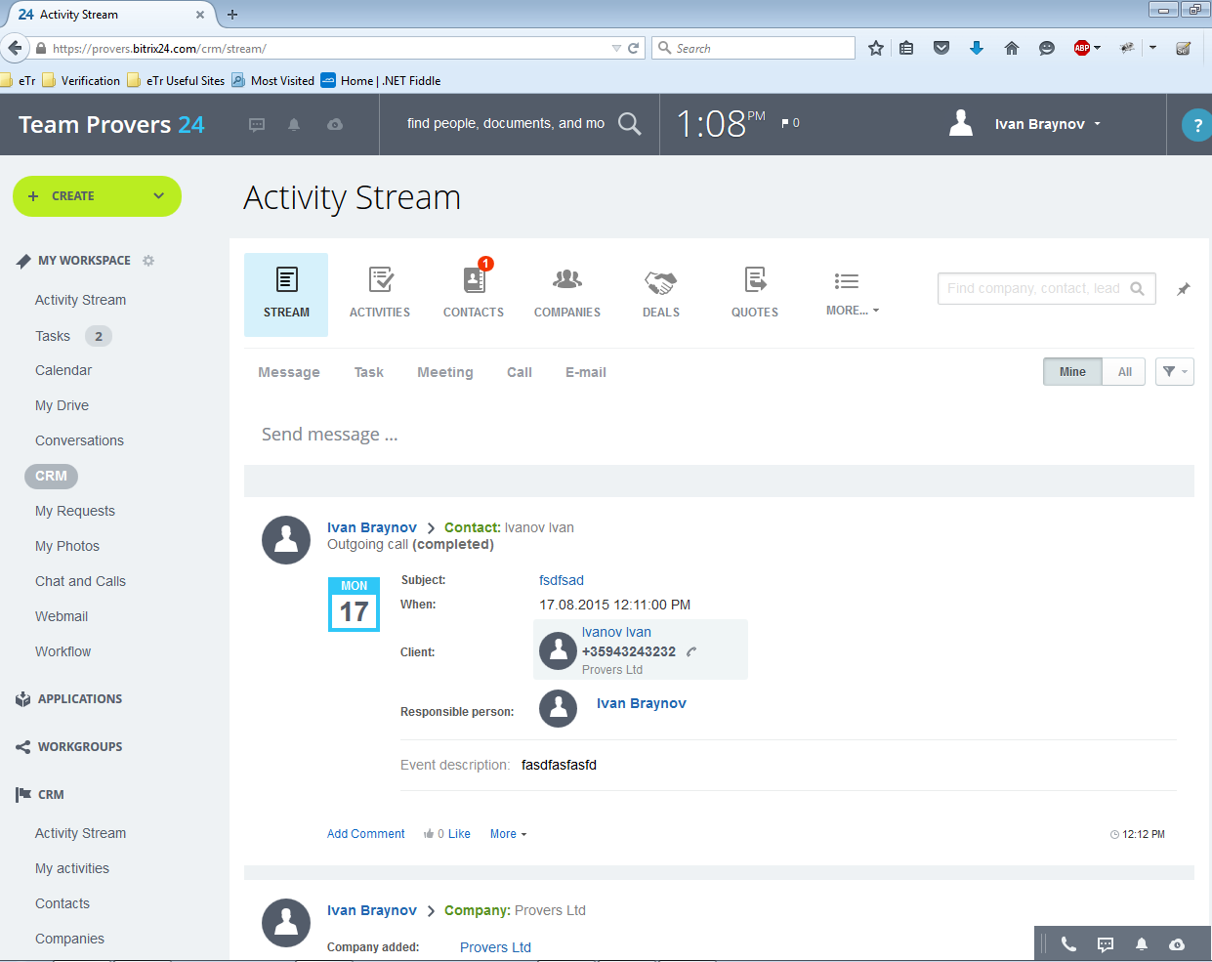

1. Contacts

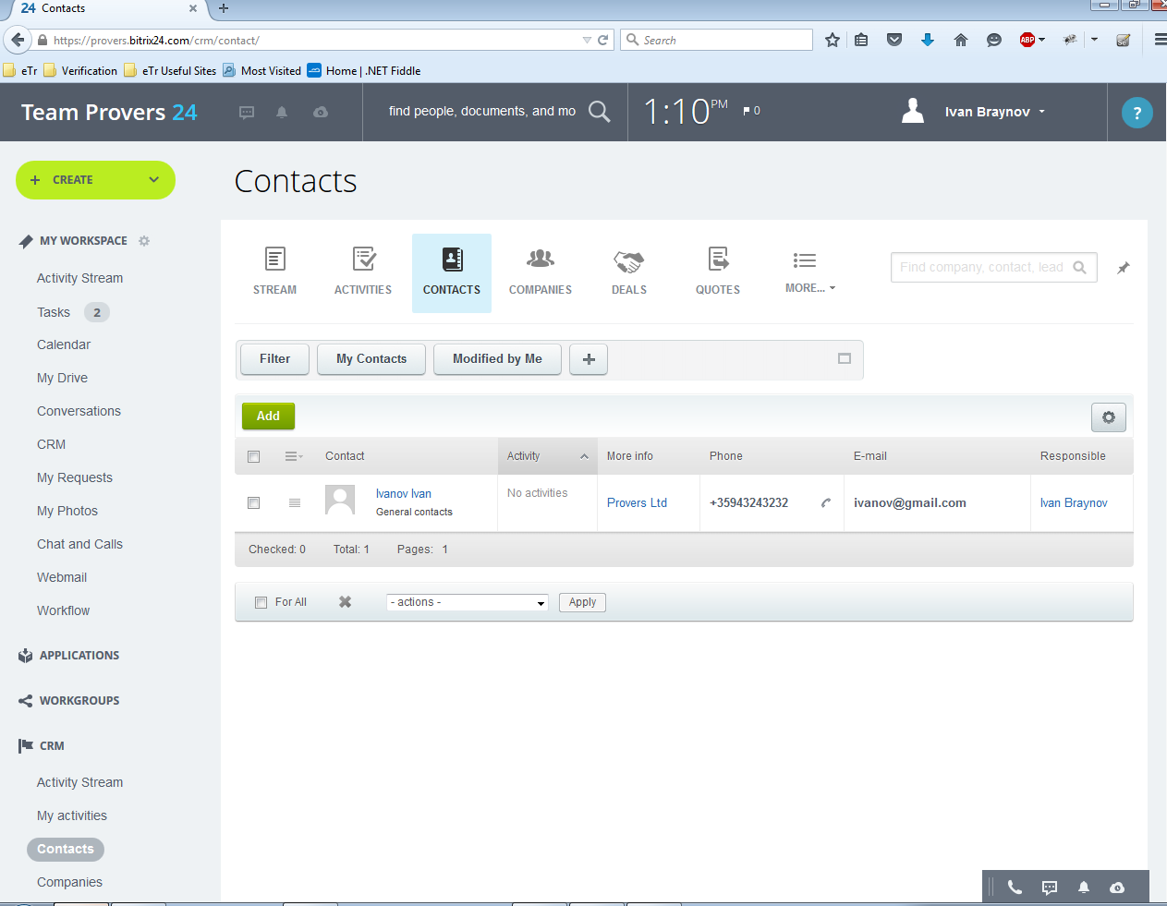

1. Companies

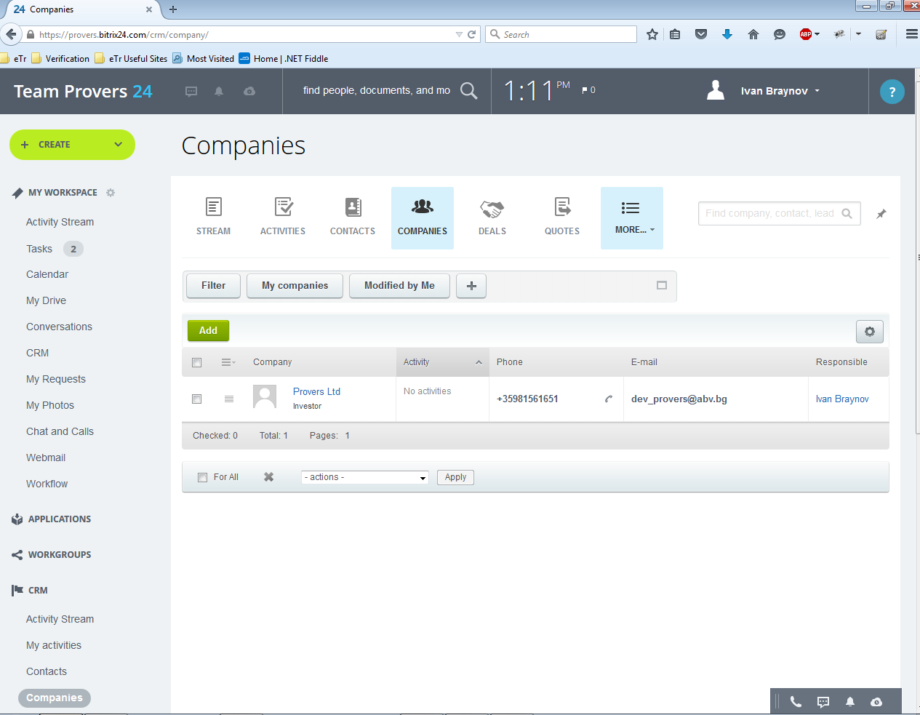

1. Activities

